MAXIMO CLOUD SOLUTIONS
OUR MAXIMO CLOUD PACKAGE INCLUDES:

- Maximo Cloud with redundant Infrastructure.
- Best of breed Cloud Security.
- All Hardware and Software needed to run Maximo effectively.
- Infrastructure Hardware & Software upgrades.
- Bundled Mobile Software (includes disconnected modes).
□ 99.99% Uptime.
- All patching of supporting infrastructure included.
- Maximo version upgrades included.
- 1 Production & 1 Non-Production Environment bundled.
- Disaster Recovery.
- Help Desk Support.
- Online and 800 support ticket submission.
- Industry Standard Service Level Agreement.
- Hourly Backups.
- Maximo Admin Services.
- Maximo Maintained by people with more than 15 years’ experience.
- Advanced Intrusion Detection & Prevention.
- Anti-Virus Protection.
- 24 x 7 system monitoring.
- Virtualized Servers.
- Options for hosting additional 3rd party Maximo related suites.
- Secure Maximo Integration Options.
- Maximo database options.
- Maximo Implementation and project deployment options by seasoned veterans.
- Additional options available upon request.

Grable Services is proud to offer Maximo cloud solutions & Services – the industry leading, complete asset lifecycle management that helps you maximize returns on your capital assets.

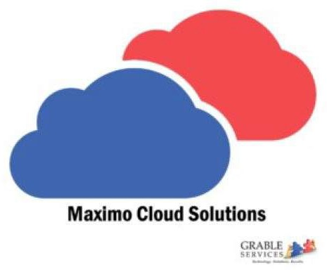

MAXIMO CLOUD SOLUTIONS
Maximo Hosting – Grable Services will host your Maximo licenses.

Maximo SaaS – Our software as a service package that includes Maximo licenses and hosting.
Maximo Platform as a Service – We maintain Maximo in the cloud for you with Tier 3 support when you need it.

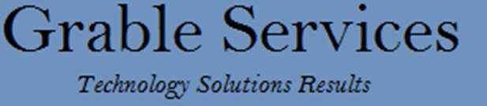

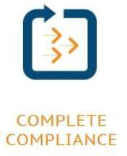
GCS provides Maximo Cloud Solutions.

THE GRABLE SERVICESS DIFFERENCE
Maximo as a cloud based service lets you eliminate hardware or software costs while focusing on what’s most important: your core business. With fast and reliable support from our team of seasoned professionals, there’s no worry involved when it comes to resolving technical issues or wondering about system administration and upgrades. We provide a full package of services with around the clock monitoring, giving you peace of mind and helping you operate more efficiently.

GCS MAXIMO DATA SHEET

DATA SHEET

OUR MAXIMO SERVICES INCLUDE:

- Maximo Best Practice Implementation & Configuration.
- EAM Consulting Services.
- Maximo Upgrades.
- Mobile Data Collection and Work Management consulting & deployment.
- Maximo Training.
- Maximo Integrations.
- Supply Chain Services.
1

2 © 2012 Grable Services, LLC. All rights reserved. Maximo and the Maximo
Logo are registered trademarks of IBM.
3 Requires GCS professional services.
4 Requires purchase of the Hosting platform.

